Game Design Document

Fill up the Following document

1. Write the title of your project.

The rise of the robots

1. What is the goal of the game?

To get to the given location not meeting any robots

1. Write a brief story of your game?

You (being one of the last humans left on earth) have to reach the

space shuttle while not encountering any robots. If you comes in

contact with you, you will have to start again(with your 2nd life)

1. Which are the playing characters of this game?

* Playing characters are the ones which respond to the user based on the input from the user
* Cars, monkeys, dinos, wizards etc, are the playing characters in the game.

|  |  |  |
| --- | --- | --- |
| Number | Character Name | What can this character do? |
| 1 | human | Move when arrow keys are pressed |
| 2 |  |  |
| 3 |  |  |
| 4 |  |  |
| 5 |  |  |
| 6 |  |  |
| 7 |  |  |
| 8 |  |  |

1. Which are the Non Playing Characters of this game?

* Non Playing characters are the ones which don't have an action or a behaviour when the user interacts with the game.
* Hurdles, stones, bananas, coins, etc are non playing characters in the game.

|  |  |  |
| --- | --- | --- |
| Number | Character Name | What can this character do? |
| 1 | robots | Terminate humans if they come in contact with them |
| 2 |  |  |
| 3 |  |  |
| 4 |  |  |
| 5 |  |  |
| 6 |  |  |
| 7 |  |  |
| 8 |  |  |

How do you plan to make your game engaging?

The players will be taken through the journey of the human as they overcome the robots to make it to the space shuttle and finally reunite with their family.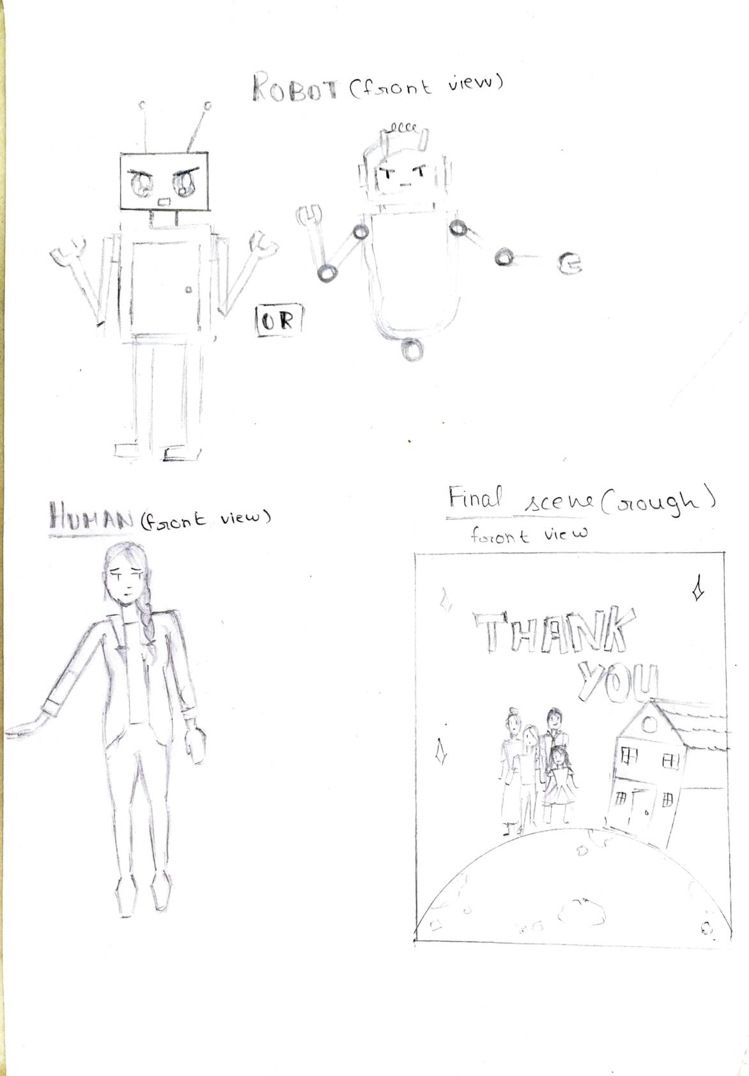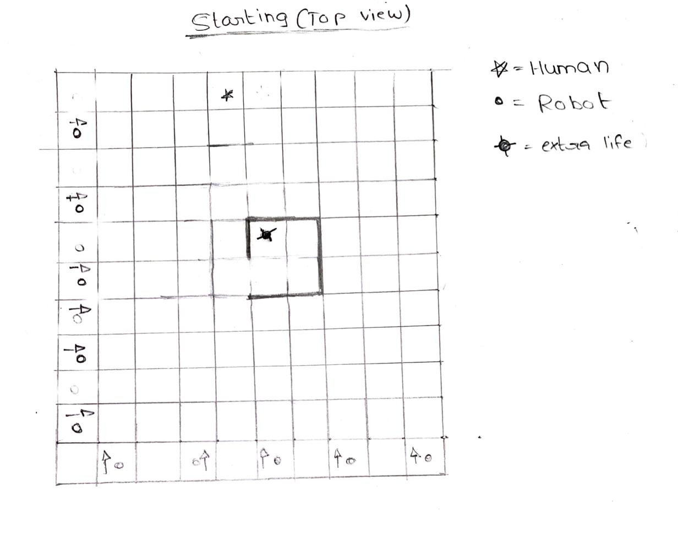

Draw your imagination of this game. What does this game look like?

* Draw the game either on your computer or on paper,
* Add images of scenes of the game to show each of the playing and non-playing characters at least once.